LP V

# Problem Statement 01 :

Implement multi threaded client/server Process communication using RMI

**Create 4 Files**

AddClient.java

AddServer.java

AddServerImpl.java

AddServerIntf.java

Imports for all

Import java.rmi.*

Import java.rmi.server.*

AddServerIntf :

It defines the interface and the function

Extends Remote

Public interface AddServerIntf extends Remote{

Public double add(double d1 , double d2 ) throws RemoteException ;

}

import *java*.*rmi*.*\**;

*public* *interface* AddServerIntf *extends* Remote{

double *add*(double d1,double d2) *throws* RemoteException;

}

AddServerImpl.java

Extends UnicastRemoteObject

Implements AddServerIntf

import *java*.*rmi*.*\**;

import *java*.*rmi*.*server*.*\**;

*public* *class* AddServerImpl *extends* UnicastRemoteObject *implements* AddServerIntf{

*public* *AddServerImpl*() *throws* RemoteException{}

*public* double *add*(double d1,double d2) *throws* RemoteException{

*return* (d1+d2);

}

}

AddServer.java

Import

Try

Create object of AddServerImpl

Catch

naming.bind(“AddServer”,object);

import *java*.*rmi*.*\**;

*public* *abstract* *class* AddServer {

*public* *static* void *main*(String[] args){

*try*{

AddServerImpl addServerImpl = *new* *AddServerImpl*();

Naming.*bind*("AddServer",addServerImpl);

}*catch*(Exception e){

System.*out*.*println*("Exception "+e);

}

}

}

AddClient :

// main

String addServerURL = “rmi://”+args[0]+ “/AddServer”

AddServerIntf addServerIntf = (AddServerIntf) Naming.lookup(addServerURL)

import *java*.*rmi*.*\**;

import *java*.*rmi*.*server*.*\**;

*public* *class* AddClient{

*public* *static* void *main*(String[] args) {

*try*{

String addServerURL = "rmi://"+args[0]+"/AddServer";

AddServerIntf addServerIntf = (AddServerIntf)Naming.*lookup*(addServerURL);

System.*out*.*println*("Enter the 1st Number");

double d1 = Double.*valueOf*(args[1]).*doubleValue*();

System.*out*.*println*("Enter the 1st Number");

double d2 = Double.*valueOf*(args[1]).*doubleValue*();

System.*out*.*println*("The sum is" + addServerIntf.*add*(d1, d2));

}*catch*(Exception e){

System.*out*.*println*("Exception "+e);

}

}

}

How to Execute ?

Sudo apt-get install openjdk-8-jdk

Java –version

sudo update-java-alternatives --set /usr/lib/jvm/java-1.8.0 openjdk-amd64

javac *.java

rmic AddServerImpl

rmiregistry

java AddServer

java AddClient "127.0.0.1" 5 10

Theory :

RMI (Remote Method Invocation) is a Java-based technology that enables communication and interaction between objects in a distributed system. It allows objects residing on different Java Virtual Machines (JVMs) to invoke methods on remote objects as if they were local objects, making it easier to build distributed applications in Java.

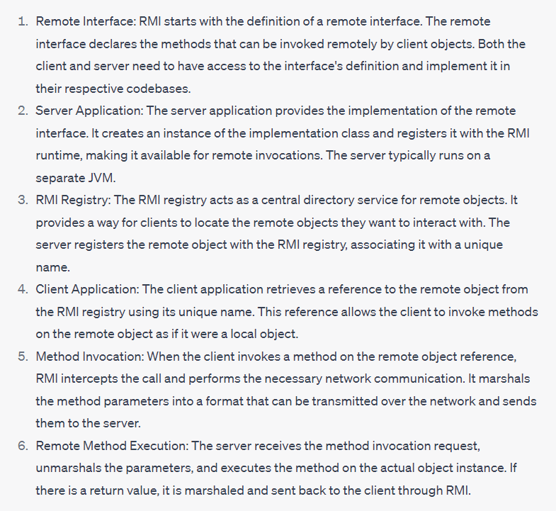

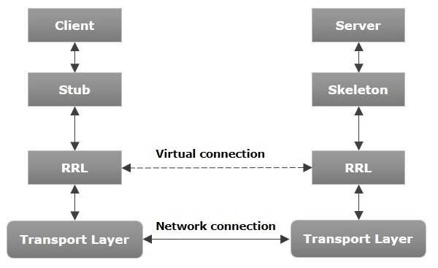

**Stub**

A stub is a representation (proxy) of the remote object at client. It resides in the client system; it acts as a gateway for the client program.

Responsibilities :

1. Initiate remote calls
2. Marshall arguments to be sent
3. Inform the RRL to invoke the call
4. Unmarshall the return value
5. Inform the RRL the call is complete

Skeleton − This is the remote object which resides on the server side. stub communicates with this skeleton to pass requests to the remote object.

1. Unmarshall the incoming arguments from the client
2. Calling the actual remote object implementation
3. Marshaling the return value for the transport back to the client

RRL(Remote Reference Layer) −

It is the layer which manages the references made by the client to the remote object.

* When the client-side RRL receives the request, it invokes a method called invoke() of the object remoteRef. It passes the request to the RRL on the server side.

A remote object is an object whose method can be invoked from another JVM

# Problem Statement 02 :

To develop any distributed application through implementing client communication programs based on Java Sockets

## Theory :

session layer

Bidirectional

The client in socket programming must know two information:

1. IP Address of Server, and
2. Port number.

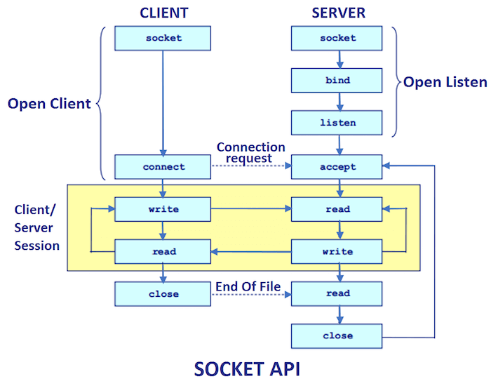

## Code :

Two Files

* Client

// *client*

import *java*.*io*.*\**;

import *java*.*net*.*\**;

import *java*.*util*.*\**;

*public* *class* client {

*public* *static* void *main*(String[] args) *throws* Exception {

*try* {

Socket s = *new* *Socket*("127.0.0.1", 3333);

DataInputStream din = *new* *DataInputStream*(s.*getInputStream*());

DataOutputStream dout = *new* *DataOutputStream*(s.*getOutputStream*());

Scanner sc = *new* *Scanner*(System.*in*);

String str = "", str2 = "";

*while* (!str.*equals*("stop")) {

System.*out*.*print*("Client : ");

str = sc.*next*();

dout.*writeUTF*(str);

str2 = din.*readUTF*();

System.*out*.*println*("Server : " + str2);

}

dout.*close*();

din.*close*();

sc.*close*();

s.*close*();

} *catch* (Exception e) {

System.*out*.*println*(e);

}

}

}

* Server

import *java*.*io*.*\**;

import *java*.*net*.*\**;

import *java*.*util*.*\**;

*public* *class* server {

*public* *static* void *main*(String[] args) *throws* Exception {

*try* {

ServerSocket ss = *new* *ServerSocket*(3333, 0, null);

Socket s = ss.*accept*();

DataInputStream din = *new* *DataInputStream*(s.*getInputStream*());

DataOutputStream dout = *new* *DataOutputStream*(s.*getOutputStream*());

Scanner sc = *new* *Scanner*(System.*in*);

String str = "", str2 = "";

*while* (!str.*equals*("stop")) {

str2 = din.*readUTF*();

System.*out*.*print*("Client : " + str2);

System.*out*.*println*("Server : ");

str = sc.*next*();

dout.*writeUTF*(str);

}

sc.*close*();

din.*close*();

dout.*close*();

s.*close*();

ss.*close*();

} *catch* (Exception e) {

System.*out*.*println*(e);

}

}

}

## Run :

Javac *.java

Java server

Java client

# Problem Statement 03 :

Develop any distributed application using CORBA to demonstrate object brokering. (Calculator operations).

CORBA (Common Object Request Broker Architecture) is a middleware technology that facilitates communication and interoperability between software components and systems. It is a standard defined by the Object Management Group (OMG) and provides a platform-independent mechanism for different software objects to communicate and interact with each other, regardless of their programming language or operating system.

1. Platform independent
2. Facilitates communication between devices

Common Object Request Broker Architecture

It is a collection of objects that isolates the requesters of a service from the providers by well defined encapsulating interface

CORBA differs from others as CORBA objects can

* Can run on any platform
* Can be located anywhere on the network
* Can be written in any language that has IDL mapping

CORBA is a client server system where client processes on the client machines can invoke operations on objects located on server machines

It was designed for heterogenous system

**ORB**

* Additional to RMI it has an extra layer of ORB
* The ORB manages the communication between the objects by invoking methods on remote objects and passing the parameters and return values between them.
* Each CORBA object is identified by an interface in a language called interface definition language
* ORB is a distributed service that implements the request of the remote object
* It locates the remote object on the network , communicates the request to the object waits for the results and communicates the result back to the client
* ORB implements location transparency
* In CORBA, an object request broker (ORB) acts as a middleware between the client and the server
* The ORB also provides services such as security, naming, and transaction management.

**Interface and IDL :**

This interface tells which methods the object exports and what parameters are required

CORBA provides a framework for objects in different languages and running on different operating systems to communicate with each other, regardless of where they are located on a network.

It uses an **interface definition language (IDL)** to describe the methods and attributes of objects, which are then used to generate code in different programming languages.. This allows developers to write distributed applications in different languages and running on different platforms, as long as they adhere to the CORBA standards.

IDL is used to define the interface .

Interface provides the methods that an object exports and specifies its parameters

One of the advantages of CORBA is its flexibility in terms of language and platform independence. It can be used to build distributed systems in different programming languages, such as C++, Java, Python, and others. Additionally, it can be used to integrate legacy systems and applications with modern ones, as long as they adhere to the CORBA standards.

Files :

1. ReverseModule.idl
2. ReverseImpl
3. ReverseClient
4. ReverseServer

problem3

-----------------------------------------------------------------------------------

ReverseModule.idl

module ReverseModule{

interface Reverse{

string (in string str);

};

};

---------------------------------------------------------------------------------

//ReverseImpl

import ReverseModule.ReversePOA;

public class

extends ReversePOA {

public String reverse_string(String name) {

StringBuffer str = new StringBuffer(name);

str.reverse();

return ("Server Send " + str);

}

}

------------------------------------------------------------------------------

//ReverseClient

import ReverseModule.*;

import java.util.Scanner;

import org.omg.CORBA.*;

import org.omg.CosNaming.*;

import org.omg.CosNaming.NamingContextPackage.*;

import org.omg.PortableServer.*;

class ReverseClient {

public static void main(String args[]) {

try {

// initialize the ORB

ORB orb = ORB.init(args, null);

NamingContextExt ncRef = NamingContextExtHelper.narrow(

orb.resolve_initial_references("NameService")

);

Reverse reverse = ReverseHelper.narrow(ncRef.resolve_str("Reverse"));

System.out.println("Enter String : ");

Scanner sc = new Scanner(System.in);

String str = sc.next();

String revStr = reverse.reverse_string(str);

System.out.println(revStr);

} catch (Exception e) {

e.printStackTrace();

}

}

}

------------------------------------------------------------------------------

//ReverseServer

import ReverseModule.*;

import org.omg.CORBA.*;

import org.omg.CosNaming.*;

import org.omg.CosNaming.NamingContextPackage.*;

import org.omg.PortableServer.*;

public class ReverseServer {

public static void main(String[] args) {

try {

ORB orb = ORB.init(args, null);

POA rootPOA = POAHelper.narrow(orb.resolve_initial_references("RootPOA"));

rootPOA.the_POAManager().activate();

Reverse h_ref = ReverseHelper.narrow(

rootPOA.servant_to_reference(new ReverseImpl())

);

NamingContextExt ncRef = NamingContextExtHelper.narrow(

orb.resolve_initial_references("NameService")

);

NameComponent path[] = ncRef.to_name("Reverse");

ncRef.rebind(path, h_ref);

orb.run();

} catch (Exception e) {

System.out.println(e);

}

}

}

------------------------------------------------------------------------------

# Problem Statement 04 :

# Problem Statement 05 :

Develop a distributed system, to find sum of N elements in an array by distributing N/n elements to n number of processors MPI or OpenMP. Demonstrate by displaying the intermediate sums calculated at different processors.

## Theory :

MPI (Message Passing Interface) is a standardized communication protocol and library that allows parallel computing across multiple processors or nodes in a distributed computing environment. It enables communication and coordination among different processes running on separate nodes, typically used for high-performance computing (HPC) applications

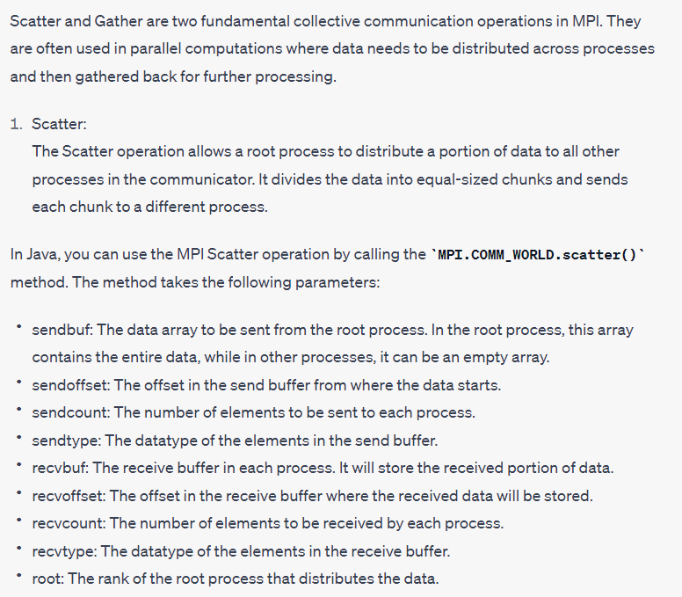

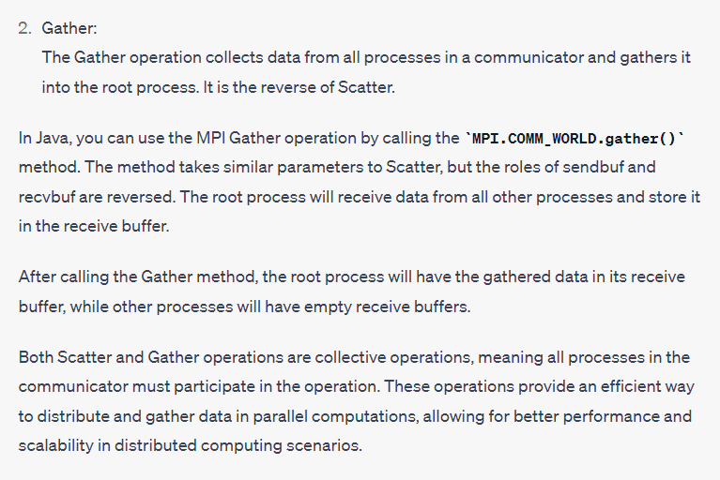

## Code :

problem5

--------------------------------------------------------------------------------

import *mpi*.*MPI*;

*public* *class* arrSum {

*public* *static* void *main*(String[] args) {

MPI.*Init*(args);

int rank = MPI.*COMM_WORLD*.*Rank*();

int size = MPI.*COMM_WORLD*.*Size*();

int unitsize = 5, root = 0;

int send_buffer[] = *new* int[unitsize * size];

int recieve_buffer[] = *new* int[unitsize];

int new_receiver_buffer[] = *new* int[size];

*if* (rank == root) {

int total = unitsize * size;

*for* (int i = 0; i < total; i++) send_buffer[i] = i + 1;

}

MPI.*COMM_WORLD*.*Scatter*(

send_buffer,

0,

unitsize,

MPI.*INT*,

recieve_buffer,

0,

unitsize,

MPI.*INT*,

root

);

*for* (int i = 1; i < unitsize; i++) recieve_buffer[0] += recieve_buffer[i];

System.*out*.*println*(

"Intermediate sum at " + rank + " is " + recieve_buffer[0]

);

MPI.*COMM_WORLD*.*Gather*(

recieve_buffer,

0,

1,

MPI.*INT*,

new_receiver_buffer,

0,

1,

MPI.*INT*,

root

);

*if* (rank == root) {

int total = 0;

*for* (int i = 0; i < size; i++) total += new_receiver_buffer[i];

System.*out*.*println*("Total sum is " + total);

}

MPI.*Finalize*();

}

}

What are the things to remember in here

1. MPI.Init(args)
2. Int rank = MPI.COMM_WORLD.Rank();
3. Int size = MPI.COMM_WORLD.Size();
4. int uintSize = 5
5. Root = 0;
6. Send_buffer[uintSize*size)
7. recieve_buffer[uintSize]
8. New_recive_buffer[size]
9. if(root==rank)
10. Total_elements = uintSize*size
11. Take input of array in send_buffer[i] = i+1;
12. Scatter data to the processes
13. MPI.Scatter(send_buffer,0,uintSize,MPI.INT,recieve_buffer,0,uintSize,MPI.INT,root)
14. Aggregate the output at the recieve_buffer[0];
15. Intermediate sum at the process
16. MPI.COMM_WORLD.Gather(recive_buffer,0,1,MPI.INT,recieve_buffer,0,1 ,MPI.INT,root)
17. Calculate total_sum for ( i = 0 to size ) total_sum+=new_recieve_buffer[i]
18. MPI.finalize()

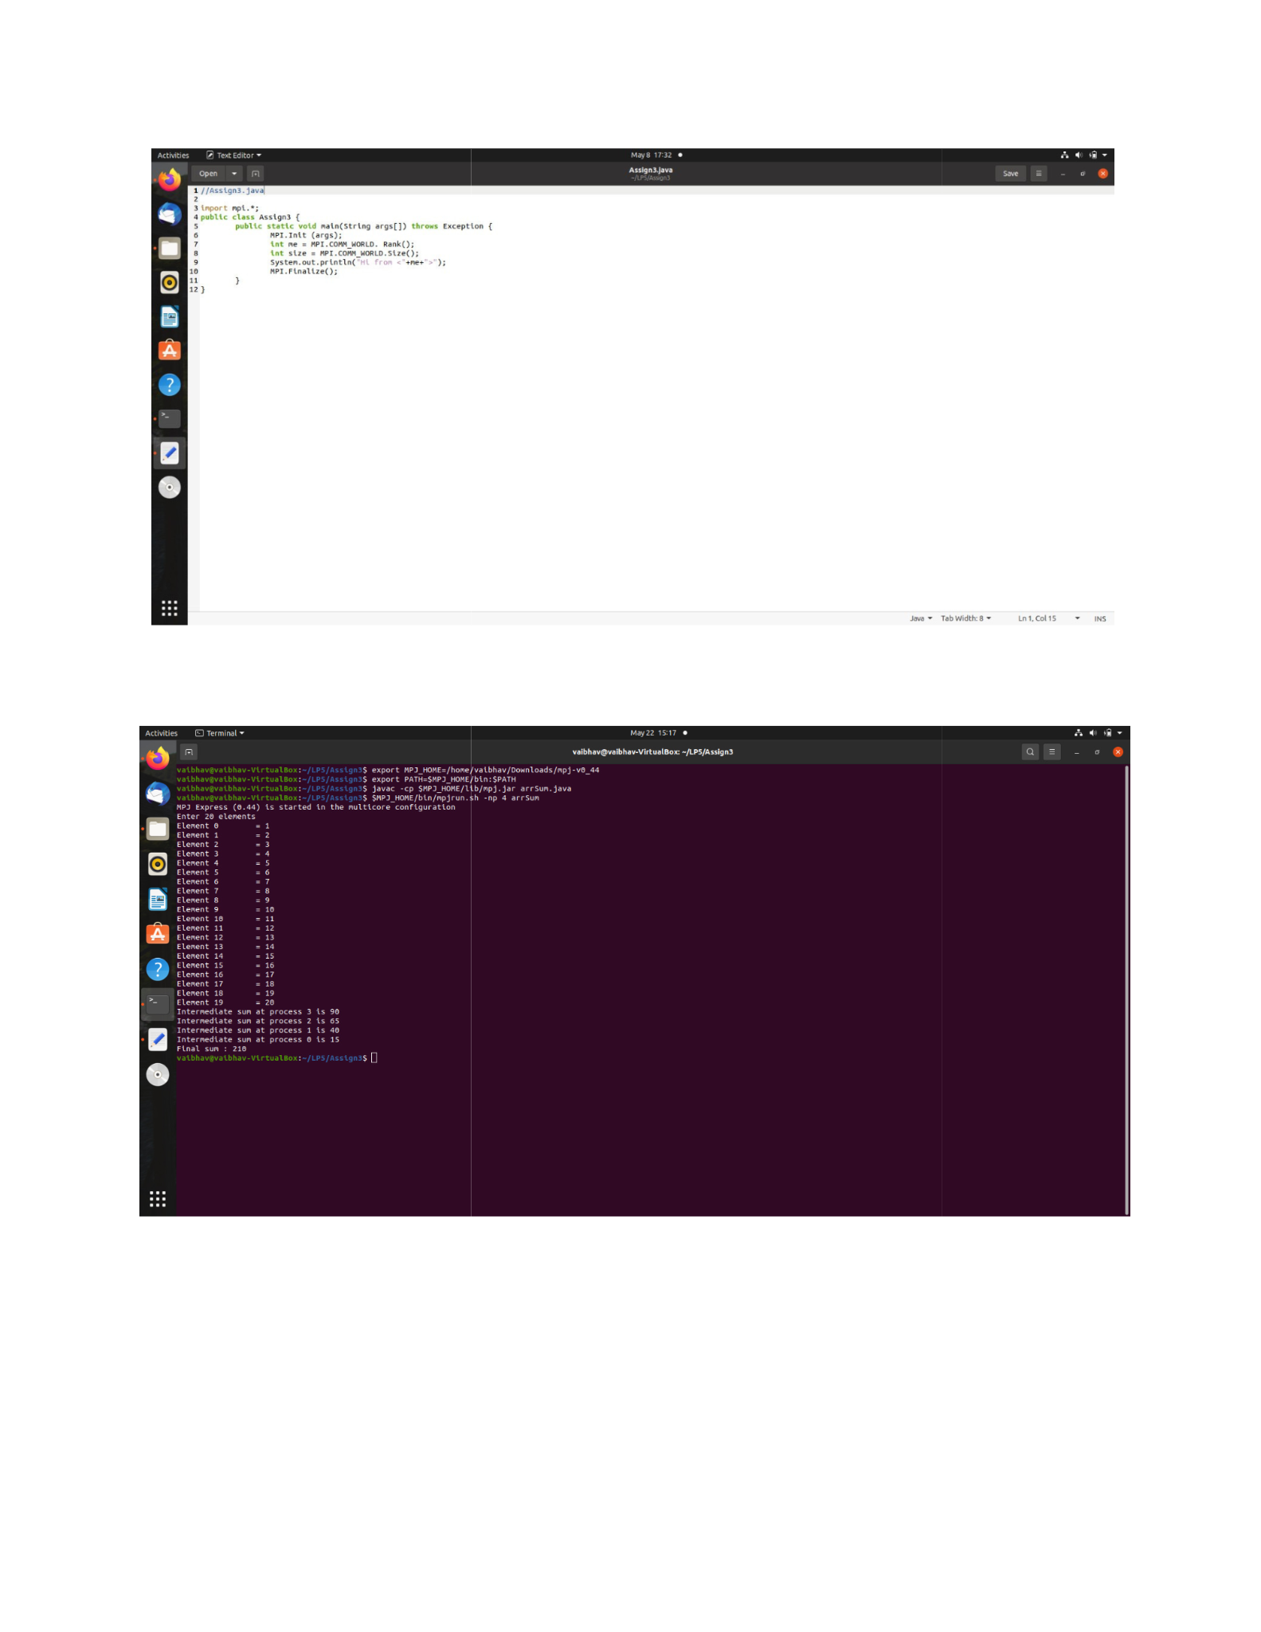

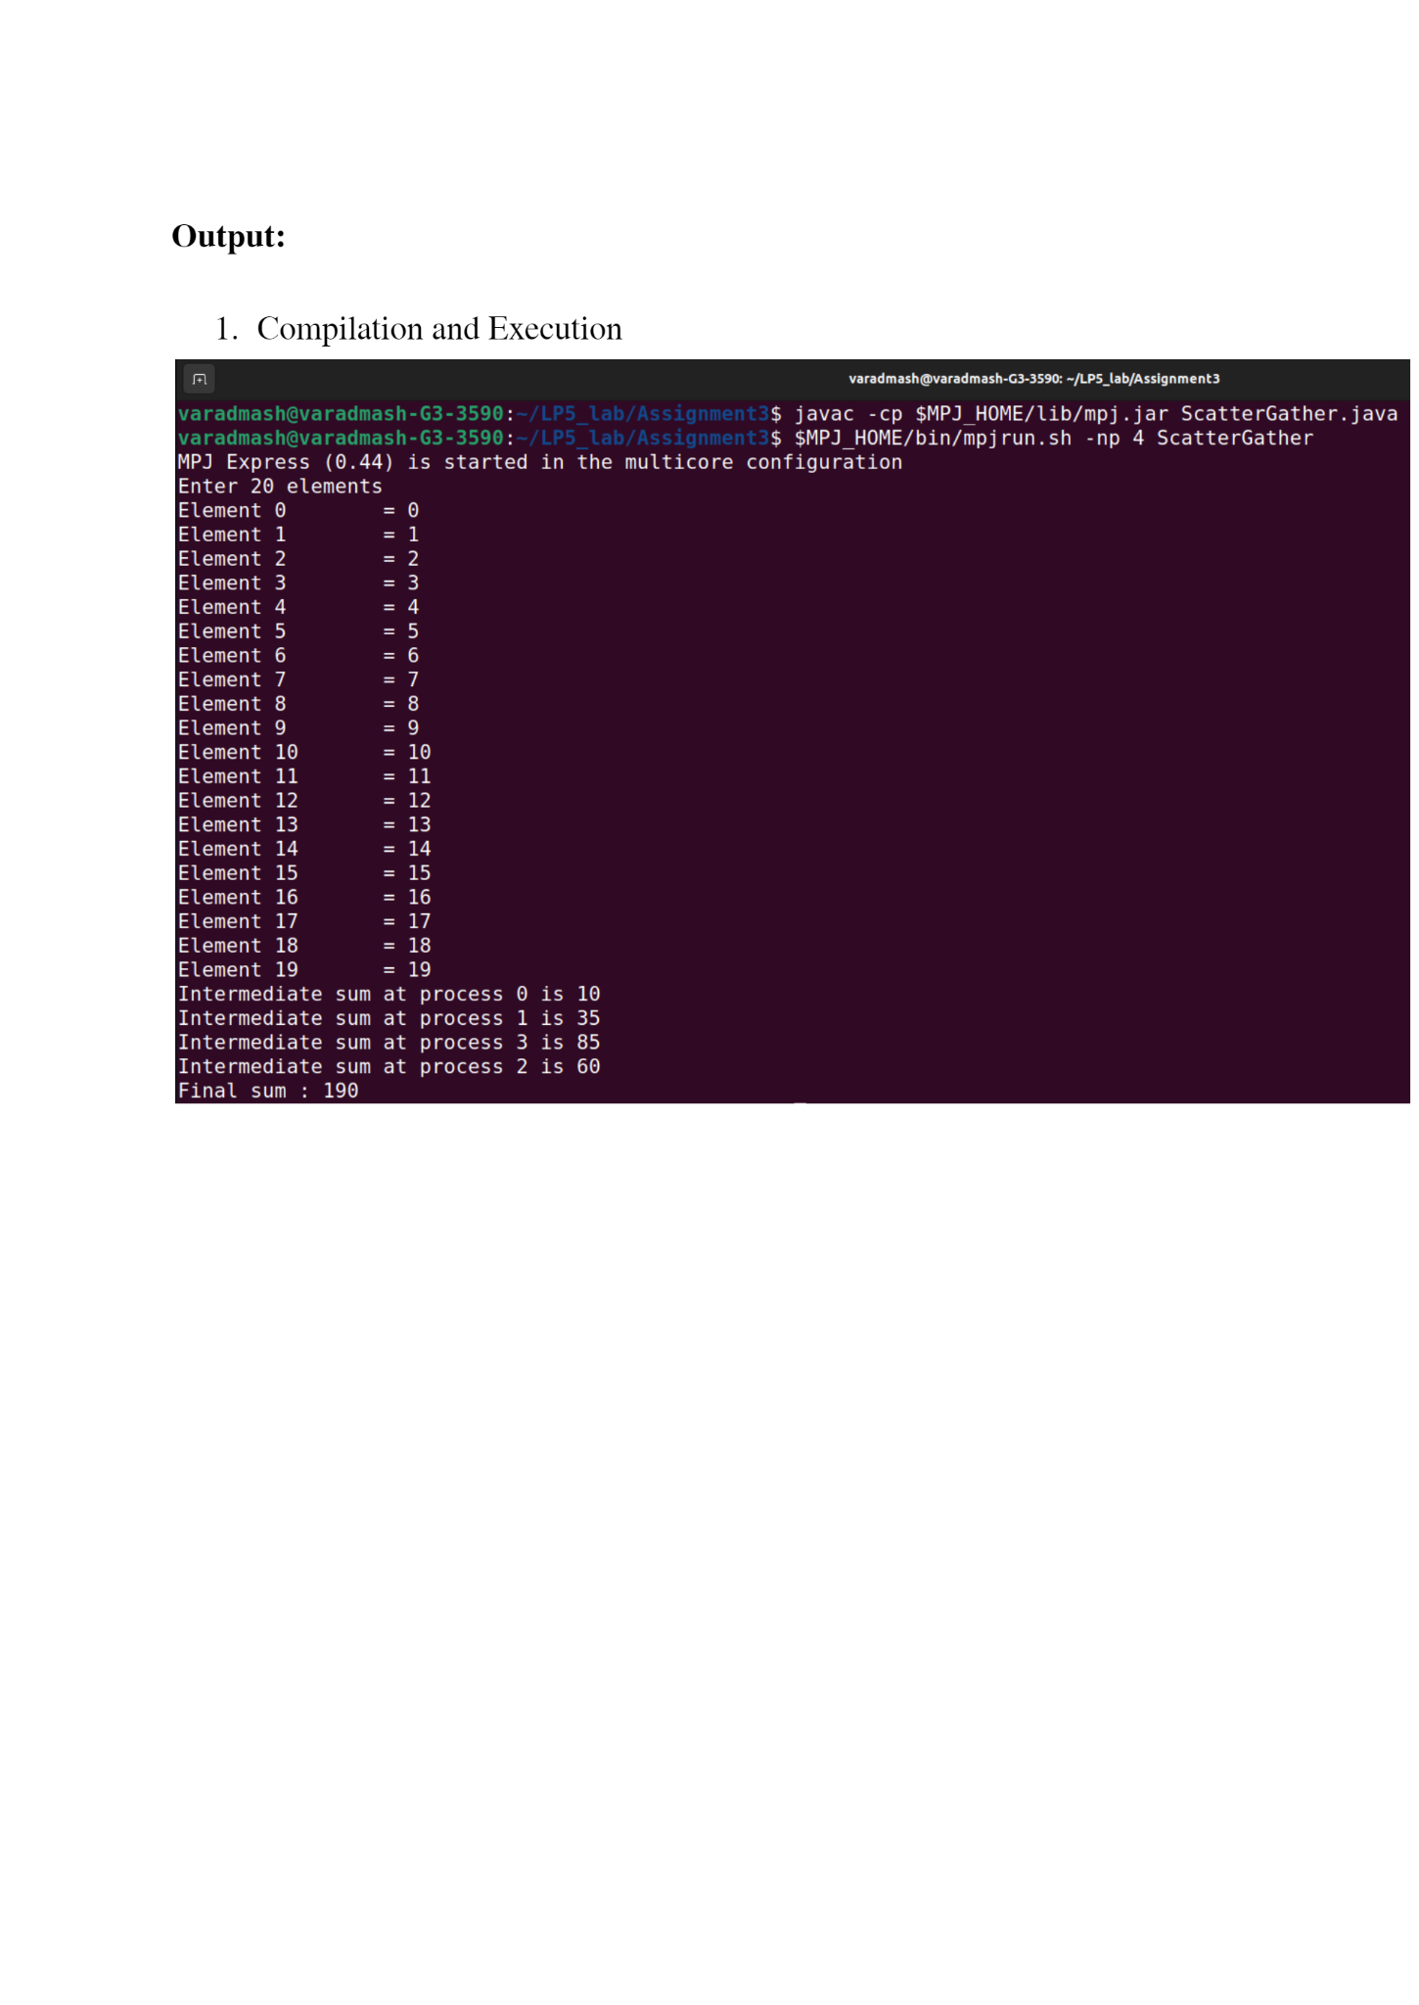

1. Compile with the mpj.jar file in the lib
2. Location home / lib / mpj.jar
3. javac -cp “location of mpj.jar” arrSum.java
4. home/bin/mpjrun.sh -np 4 arrSum

# Problem Statement 06 :

Implement Berkeley algorithm for clock synchronization

## Theory :

Berkeley Algorithm :

The goal of the algorithm is to synchronize the clocks of multiple computers in a network, even if there are significant variations in clock drift rates among the computers.

The basic idea of the Berkeley algorithm is as follows:

1. One computer is elected as the time server or coordinator. This can be done through a voting process or a predetermined selection.
2. The time server periodically polls the other computers in the network for their local clock values.
3. Upon receiving the responses from the other computers, the time server calculates the average clock value, excluding outliers that deviate significantly from the average.
4. The time server then sends the adjusted time value to each computer, which adjusts its local clock to match the new value.
5. The process is repeated periodically to continuously synchronize the clocks of all computers in the network.

By using this algorithm, the clocks of the computers in the network can be brought into reasonable agreement, reducing the effects of clock drift and maintaining a synchronized notion of time across the distributed system.

## Code

This is an easy experiment :

Two files : client.java server.java

Client :

1. Extends thread class
2. while(true){
3. Create a socket sc = new Socket(“localhost”,port)
4. inputStream
5. OutputStream
6. Int clientTime = System.currentTimeMillis();
7. outPutStream.writeLong(clientTime)
8. Long ack = inputStream.readUTF()
9. print(ack)
10. Long avg = inputStream.readLong()
11. Print currentTIme
12. Print average time
13. Close all
14. Thread.sleep(1000);

//*client.java*

import *java*.*io*.*\**;

import *java*.*net*.*\**;

import *java*.*util*.*\**;

*public* *class* client *extends* Thread {

*public* *static* void *main*(String[] args) {

*try* {

// *Connect to the server*

*while* (true) {

Socket socket = *new* *Socket*("localhost", 12345);

DataInputStream inputStream = *new* *DataInputStream*(

socket.*getInputStream*()

);

DataOutputStream outputStream = *new* *DataOutputStream*(

socket.*getOutputStream*()

);

long clientTime = System.*currentTimeMillis*();

outputStream.*writeLong*(clientTime);

String acknowledgment = inputStream.*readUTF*();

System.*out*.*println*(acknowledgment);

long averageTime = inputStream.*readLong*();

System.*out*.*println*("-------------------------------------");

System.*out*.*println*("Current time : " + *new* *Date*(clientTime));

System.*out*.*println*("Adjusted time : " + *new* *Date*(averageTime));

System.*out*.*println*("-------------------------------------");

inputStream.*close*();

outputStream.*close*();

socket.*close*();

Thread.*sleep*(10000);

}

} *catch* (Exception e) {

System.*out*.*println*(e);

}

}

}

Server.java

1. Does not extend thread class
2. Create a serverSocket
3. Create an arrayList<Long> clientTimes
4. clientTimes.add(System.currentTimeMillis());
5. while(client.times.size()<1000){
   1. Socket sc = serverSocket.accept()
   2. inputStream
   3. OutputStream
   4. clientTime = inputStream.readLong();
   5. Add it to the ArrayList
   6. outstream.writeUTF(“This is the time received by the server” + clientTime)
   7. Calculate the sum
   8. Calculate avg
   9. outputStream.writeLong(avg);
   10. Close all streams

//*server.java*

import *java*.*io*.*\**;

import *java*.*net*.*\**;

import *java*.*util*.*\**;

*public* *class* server *extends* Thread {

*public* *static* void *main*(String[] args) {

*try* {

ServerSocket serverSocket = *new* *ServerSocket*(12345);

List<Long> clientTimes = *new* ArrayList<>();

clientTimes.*add*(System.*currentTimeMillis*());

System.*out*.*println*("Server is running. Waiting for clients...");

*while* (clientTimes.*size*() < 1000) {

System.*out*.*println*("-------------------------------------");

Socket clientSocket = serverSocket.*accept*();

DataInputStream inputStream = *new* *DataInputStream*(

clientSocket.*getInputStream*()

);

DataOutputStream outputStream = *new* *DataOutputStream*(

clientSocket.*getOutputStream*()

);

System.*out*.*println*("listening to client timing ");

long clientTime = inputStream.*readLong*();

clientTimes.*add*(clientTime);

outputStream.*writeUTF*(

"Time received by the server." + *new* *Date*(clientTime)

);

long sum = 0, n = clientTimes.*size*();

*for* (int i = 0; i < n; i++) {

sum += clientTimes.*get*(i);

}

System.*out*.*println*("Number of client to be synchronized " + n);

System.*out*.*println*("-------------------------------------");

long averageTime = sum / clientTimes.*size*();

outputStream.*writeLong*(averageTime);

inputStream.*close*();

outputStream.*close*();

clientSocket.*close*();

}

serverSocket.*close*();

} *catch* (Exception e) {

System.*out*.*println*(e);

}

}

}

----------------------------------------------------------------------

# Problem Statement 07 :

Implement token ring based mutual exclusion algorithm

Token ring based mutual exclusion algorithm is a distributed algorithm used to coordinate access to shared resources in a network of interconnected nodes organized in a ring topology. The algorithm ensures that only one node at a time has exclusive access to the shared resource, preventing conflicts and maintaining consistency.

The algorithm operates by passing a token, which is a special message or control packet, around the ring. The token circulates through the nodes in a predetermined order, and a node can access the shared resource only when it possesses the token. When a node needs to access the resource, it waits until it receives the token, indicating that it is its turn to use the resource. After using the resource, the node releases the token and passes it to the next node in the ring.

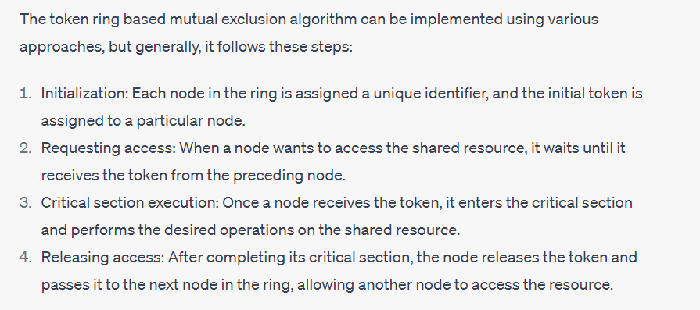

import *java*.*util*.*\**;

import *java*.*net*.*\**;

import *java*.*io*.*\**;

*public* *class* ring{

*public* *static* void *main*(String[] args) {

int sender = 0;

int receiver = 0;

int token = 0;

Scanner sc = *new* *Scanner*(System.*in*);

System.*out*.*println*("Enter number of process : ");

int n = sc.*nextInt*();

*for*(int i = 0;i<n;i++){

System.*out*.*print*(" p"+i);

}

System.*out*.*println*(" p"+0);

*while*(true){

System.*out*.*println*("-----------------");

System.*out*.*println*("Enter Sender : ");

sender = sc.*nextInt*();

System.*out*.*println*("Enter Receiver :");

receiver = sc.*nextInt*();

System.*out*.*println*("Token passes : ");

*for*(int i = token;i!=sender;i = (i+1)%n){

System.*out*.*print*(i+" -->");

}

System.*out*.*println*();

System.*out*.*println*(sender);

System.*out*.*println*("Enter data to be sent : ");

String data = sc.*next*();

*for*(int i = sender;i!=receiver;i = (i+1)%n){

System.*out*.*println*(data + " forwarded by "+i);

}

System.*out*.*println*(data + " received at " + receiver);

token = sender;

System.*out*.*println*("--------------------------");

}

}

}

# Problem Statement 08 :

Bully Algorithm:

The Bully Algorithm is a leader election algorithm where nodes with higher IDs have more priority in becoming the leader.

Ring Algorithm:

The Ring Algorithm is a leader election algorithm where nodes form a logical ring and pass a token to elect a leader.

The **bully** algorithm is a type of **Election algorithm** which is mainly used for choosing a coordinate. In a distributed system, we need some election algorithms such as **bully** and **ring** to get a coordinator that performs functions needed by other processes.

**Election algorithms** select a single process from the processes that act as coordinator. A new process is selected when the selected coordinator process crashes due to some reasons. In order to determine the position where the new copy of coordinator should be restarted, the election algorithms are used.

The **Bully** election algorithm is as follows:

Let's assume that **P** is a process that sends a message to the coordinator.

1. It will assume that the coordinator process is failed when it doesn't receive any response from the coordinator within the time interval **T**.
2. An election message will be sent to all the active processes by process **P** along with the highest priority number.
3. If it will not receive any response within the time interval T, the current process P elects itself as a coordinator.
4. After selecting itself as a coordinator, it again sends a message that process **P** is elected as their new coordinator to all the processes having lower priority.
5. If process **P** will receive any response from another process **Q** within time **T:**
   1. It again waits for time T to receive another response, i.e., it has been elected as coordinator from process **Q**.
   2. If it doesn't receive any response within time **T**, it is assumed to have failed, and the algorithm is restarted.

The Bully Algorithm is a leader election algorithm used in distributed systems, where a group of interconnected nodes or processes need to elect a leader to perform certain tasks or make decisions on behalf of the group. The algorithm ensures that the most capable node, typically the one with the highest ID, becomes the leader.

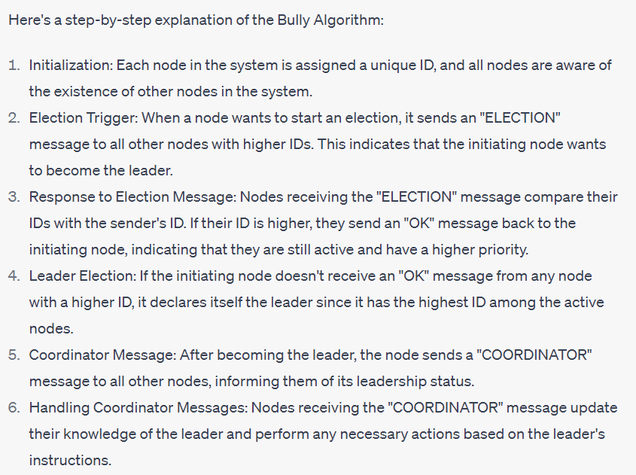

// *bully*

import *java*.*util*.*\**;

*public* *class* bully {

*static* boolean state[] = *new* boolean[1000];

*static* int n;

*static* void *up*(int process) {

*if* (state[process]) {

System.*out*.*println*("Process is already up");

} *else* {

state[process] = true;

*mess*(process);

}

}

*public* *static* void *down*(int process) {

*if* (!state[process]) {

System.*out*.*println*("Process is already down");

} *else* {

state[process] = false;

System.*out*.*println*("Process down successfully");

}

}

*static* void *mess*(int process) {

*if* (state[process]) {

System.*out*.*println*("Process" + process + " intiate election");

*for* (int i = process + 1; i < n; i++) {

System.*out*.*println*(

"election message send from process " + process + " to process " + i

);

}

*for* (int i = n - 1; i >= process; i--) {

*if* (state[i]) {

System.*out*.*println*("Coordinator message send from " + i + " to all");

*break*;

}

}

} *else* {

System.*out*.*println*("Process" + process + " is down.");

}

}

*public* *static* void *main*(String[] args) {

int choice = 0, process = 0;

Scanner sc = *new* *Scanner*(System.*in*);

System.*out*.*print*("Enter Number of Process : ");

n = sc.*nextInt*();

*for* (int i = 0; i < n; i++) {

state[i] = true;

}

System.*out*.*println*("There are " + n + "Processes are active : ");

*for* (int i = 0; i < n; i++) System.*out*.*print*("p" + i + " ");

System.*out*.*println*("\nProcess " + n + " is coordinator.");

*do* {

System.*out*.*println*("1. Up the process");

System.*out*.*println*("2. Down the process");

System.*out*.*println*("3. send message");

System.*out*.*print*("Enter the choice : ");

choice = sc.*nextInt*();

*switch* (choice) {

*case* 1*:*

System.*out*.*print*("Bring Up Process : ");

process = sc.*nextInt*();

*up*(process);

*break*;

*case* 2*:*

System.*out*.*print*("Bring Down Process : ");

process = sc.*nextInt*();

*down*(process);

*break*;

*case* 3*:*

System.*out*.*print*("Message send by Process : ");

process = sc.*nextInt*();

*mess*(process);

*break*;

}

} *while* (choice != 4);

}

}

RING ALGORITHM :

This algorithm applies to systems organized as a ring(logically or physically). In this algorithm we assume that the link between the process are unidirectional and every process can message to the process on its right only. Data structure that this algorithm uses is **active list**, a list that has a priority number of all active processes in the system

1. If process P1 detects a coordinator failure, it creates new active list which is empty initially. It sends election message to its neighbour on right and adds number 1 to its active list.
2. If process P2 receives message elect from processes on left, it responds in 3 ways:
   * (I) If message received does not contain 1 in active list then P1 adds 2 to its active list and forwards the message.
   * (II) If this is the first election message it has received or sent, P1 creates new active list with numbers 1 and 2. It then sends election message 1 followed by 2.
   * (III) If Process P1 receives its own election message 1 then active list for P1 now contains numbers of all the active processes in the system. Now Process P1 detects highest priority number from list and elects it as the new coordinator.

* If any node p thinks that the previous coordinator is crashed it has to build an election message that contains its own ID no.
* Send this to the first live successor
* Each process adds its own number and forwards the list to the next
* It is OK to have two elections at once
* When the message returns to P it checks for its own process id and knows that the circuit is completed

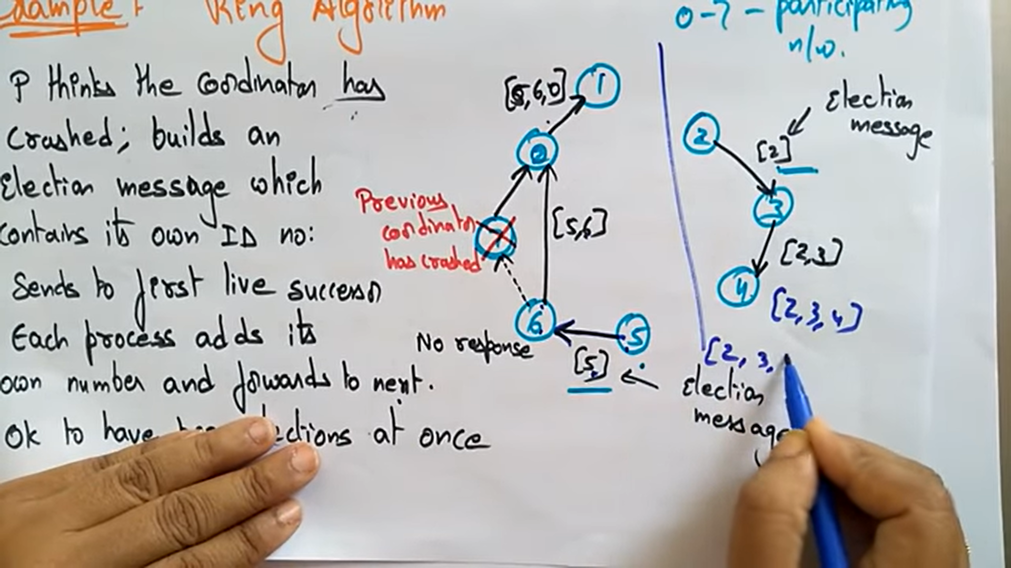

* P now circulates the coordinator message with the new highest number in the list

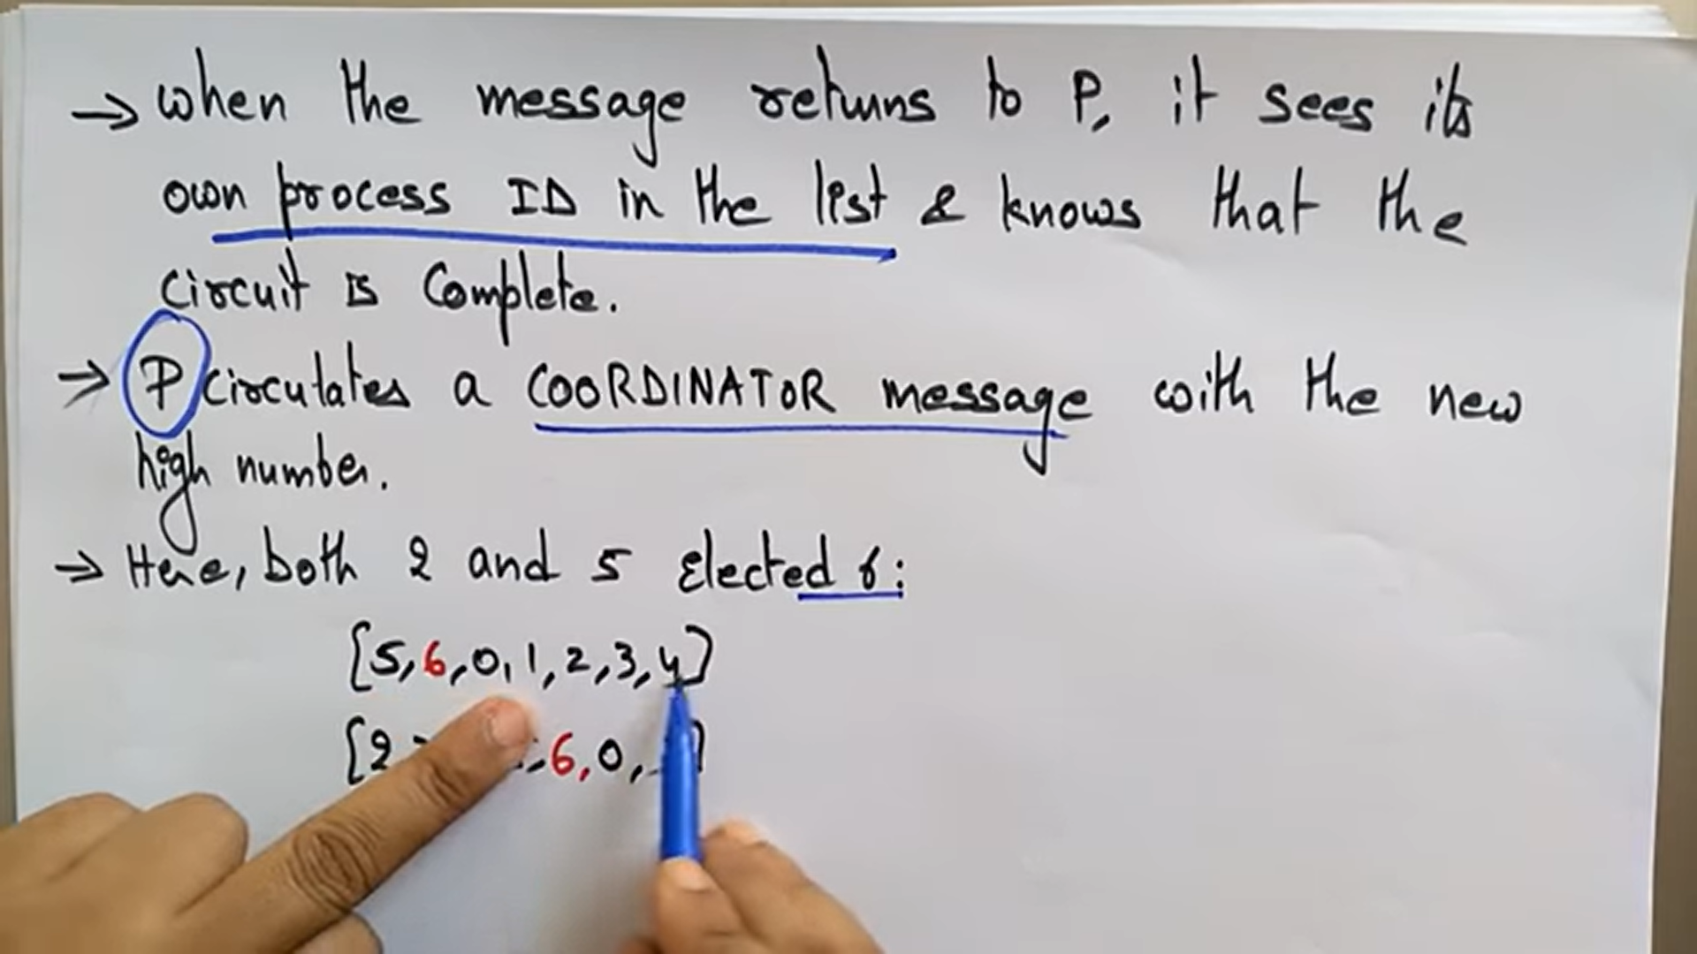

Here 6 gets elected now

What is the algorithm now ??

1. Declare state boolean array and n
2. In main function
3. Take the input for number of processes
4. Initialize state[0-n] to true
5. Initialize arr of n and arr[i] = -1
6. Print that there are n processes
7. Print n-1 process fails
8. State[n-1] = false;
9. Switch variable
10. Switch ( choice ) :
11. 1 . Election
12. 2. Exit
13. Election main fir
14. Enter the initializing process
15. Process = sc.nextInt()
16. Cur = process
17. Do {}while(cur!=process);
18. Arr[j++] = cur;
19. Next = cur + 1 % n ;
20. while(!state[next])Next = (next + 1 ) %n;
21. Process cur sends message to next
22. Cur = next;
23. Find maximum of the array
24. Cur = process
25. Do a while loop
26. Process cur Pass Coordinator to maxi message to next
27. while(cur!=process )
28. Return
29. Break

import *java*.*util*.*\**;

import *java*.*net*.*\**;

import *java*.*io*.*\**;

*public* *class* ring {

*static* boolean[] state = *new* boolean[1000];

*static* int n;

*public* *static* void *main*(String[] args) {

Scanner sc = *new* *Scanner*(System.*in*);

System.*out*.*println*("Enter the number of Processes : ");

n = sc.*nextInt*();

*for*(int i = 0;i<n;i++){

state[i] = true;

}

int[] arr = *new* int[n];

*for*(int i = 0;i<n;i++){

arr[i] = -1;

}

System.*out*.*println*("There are "+n + "Processses");

*for*(int i = 0;i<n;i++){

System.*out*.*print*("p"+i+"");

}

System.*out*.*println*("Process" + (n-1)+ "fails");

state[n-1] = false;

int choice = 0;

*do*{

System.*out*.*println*("1. Election");

System.*out*.*println*("2. Exit");

System.*out*.*println*("Enter your choice");

choice = sc.*nextInt*();

*switch*(choice){

*case* 1 *:* {

System.*out*.*println*("Enter Process who is initializing the election");

int process = sc.*nextInt*();

int cur = process , j = 0;

*do* {

arr[j++] = cur;

int next = (cur+1)%n;

*while*(!state[next]){

next =( next + 1 ) %n;

}

System.*out*.*println*("Process " + cur + "sends message to"+ next);

cur = next;

}*while*(cur!=process);

int maxi = -1;

*for*(int i = 0;i<n;i++) *if*(maxi<arr[i]) maxi = arr[i];

System.*out*.*println*("Process " + maxi + "Selected as coordinator");

cur = process;

*do*{

int next = ( cur + 1 ) %n;

*while*(!state[next] ) next = (next + 1 ) % n;

System.*out*.*println*("Process " + cur + "Pass Coordinator ( " + maxi + ") message to" + next);

cur = next;

}*while*(cur!=process);

}

*case* 2 *:* {

*return* ;

}

*default* *:* {

*break*;

}

}

}*while*(true);

}

}

# Problem Statement 09 :

Create a simple web service and write any distributed application to consume the web service

In Java, a web service is a software component or application that allows different systems to communicate and exchange data over the web using standard web protocols

It enables interoperability between various platforms and programming languages by providing a standardized way of exposing functionalities and accessing them remotely.

A web service in Java is typically implemented using the Java API for XML Web Services (JAX-WS) or Java API for RESTful Web Services (JAX-RS),

Steps :

1. Create web service
2. New Project
3. Java web → Web application
4. Project name
5. Right click on project create web service
6. Package com.unique
7. Delete hello world
8. Click on service add operation then select the parameter and two numbers int
9. Clean and build
10. Deploy
11. Test web service
12. Test Web service
13. Create a client similar to the new package
14. Create and new web service client
15. Pass the path of the web service

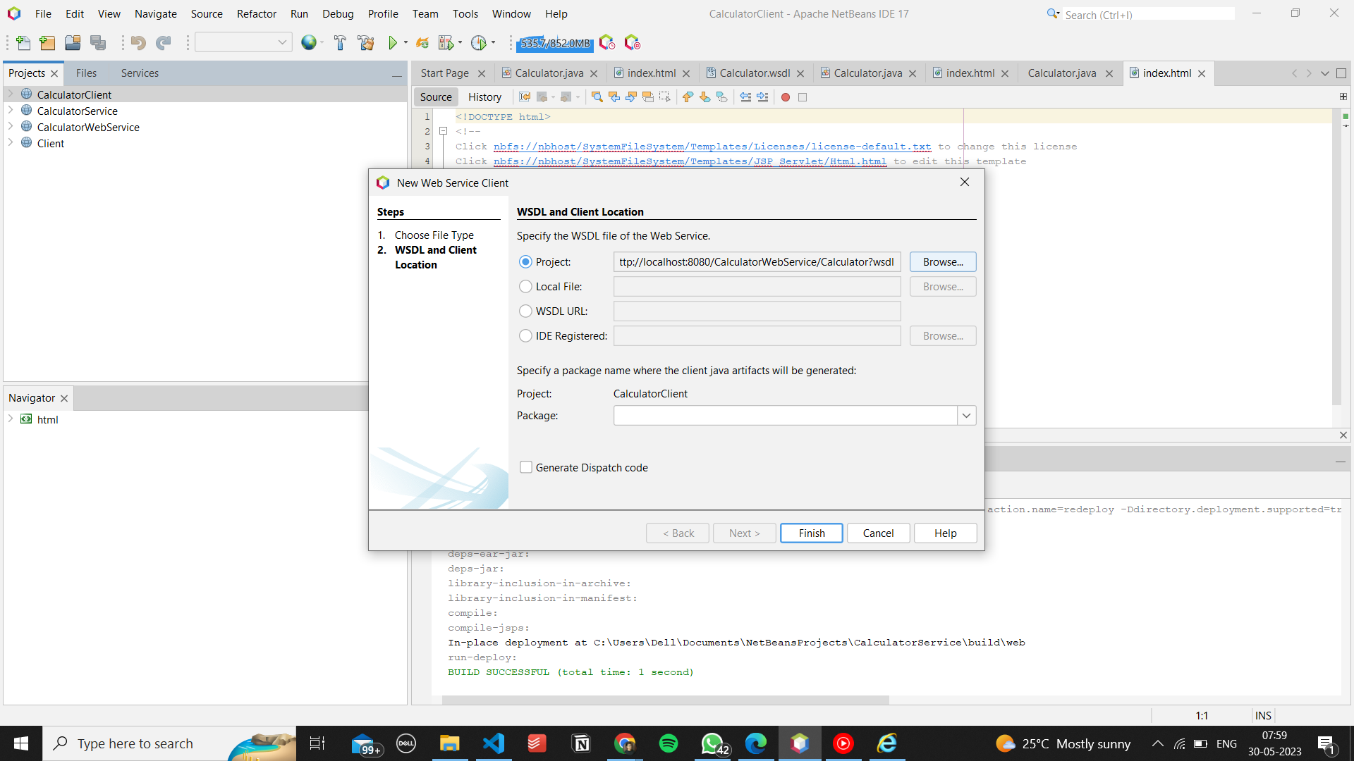

1. Web services references will contain the created method
2. Edit the index.html file
3. Name the action of the form calculator
4. Go to tools palette and select a form
5. Select input txt1
6. Select input txt2
7. Button submit
8. Now run the client
9. Go to source packages → new → servlet ( name of the servlet should be same as the name of the action in the form
10. Add information to descriptor check krna hai
11. Now drag and drop the getNumber method onto the lower end of the servlet page
12. Now inside the processRequestMethod and inside try take input of the two number s

int num1 ,num2;

num1 = Integer.parseInt(request.getParameter("txt1"));

num2 = Integer.parseInt(request.getParameter("txt2"));

out.println("<!DOCTYPE html>");

out.println("<html>");

out.println("<head>");

out.println("<title>Servlet calculator</title>");

out.println("</head>");

out.println("<body>");

out.println("<h1>" +getNumber(num1,num2)+ "</h1>");

# 